MEMORANDUM

DATE: September 4, 2020

TO: GCSAA Members

FROM: 2020 GCSAA Nominating Committee Darren J. Davis, CGCS – Chairman
RE: Affidavit of Nominations – 2021 GCSAA Officers and Directors
After careful evaluation of each perspective nominee’s qualifications, it is the Nominating Committee’s decision to place the following candidates on the slate for the 2021 GCSAA Board of Directors at the next annual meeting scheduled for Thursday, February 4, 2021.

For President: Mark F. Jordan, CGCS

For Vice President: Kevin P. Breen, CGCS

For Secretary/Treasurer: Kevin P. Sunderman, CGCS
Jeff L. White, CGCS

For Director: T.A. Barker, CGCS
Paul L. Carter, CGCS
Jon M. Christenson
Christopher A. Reverie
Marc E. Weston, CGCS

By unanimous consensus of the 2020 Nominating Committee whose signed affidavits are on record at GCSAA headquarters:
- Darren J. Davis, CGCS * Robert O. Farren, Jr., CGCS
- Donald S. Ferreri * Matt Gourlay, CGCS, MG
- Mark D. Kuhns, CGCS

This is to certify that this is a true and complete copy of the affidavit of nominations for the election of the 2021 Officers and Directors of GCSAA as submitted by the 2020 Nominating Committee and is hereby presented to the membership per Article VII, Section 1 of the GCSAA Bylaws.
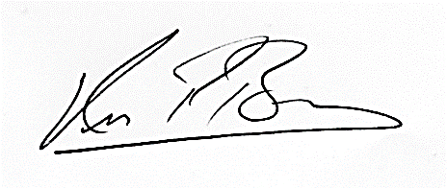
Kevin P. Breen, CGCS
GCSAA Secretary/Treasurer
kbreen@larinconadacc.com

Affidavit of Nominations Page 2

