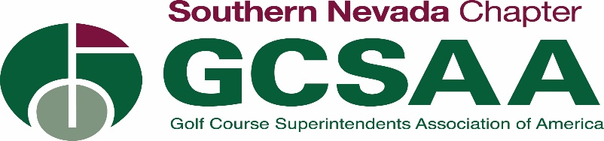

Golf as good partners and citizens in keeping employees and customers safe

- We respect the difficult position the state and Governor Sisolak are in to simultaneously keep the economy going and our citizens safe
- Golf course owners and operators in Nevada are highly supportive of the efforts to minimize the spread of COVID-19
- Operational controls at golf courses are continually established in accordance with OSHA, CDC, DHEC and other federal, state and local authorities

How golf courses are different from restaurants, bars, gyms, etc.

- The clubhouse, pro shop and/or restaurant operation is just one small part of the footprint of a golf course.
- We believe the fields of play, which typically represent over 130 acres of open space land, should be treated differently.
- The opportunity for social distancing on a golf course is much like taking a walk through one of our state or local parks.
- Golf courses can remain open for play (a wonderful and socially distancing activity for everyone to enjoy), and operators can take all the necessary precautions to keep staff and golfers safe.
- Whether utilizing a cart of walking, playing golf oxygenates the body, improves posture, and provides a place to enjoy fresh air.

Precautions taking place at golf facilities now

- Golf course operators all over America have been taking extra precautions to ensure playing golf is a safe experience that comports with all health advisories and recommendations by the Centers for Disease Control.
- Courses are adjusting the food and beverage operations to comply with all suggested and mandated restrictions, such as limiting all business to take-out food service.
- The golf industry has developed specific operations protocols that support the directive of the CDC for both “safe distancing” and environmental and sanitation management.
- All major golf organizations are sharing best practices with the entire industry.
- For employees, these protocols include but are not limited to
- Educate staff on hygiene, sanitation, and food handling to learn about epidemic prevention and control
- Educate staff to recognize the symptoms of COVID-19 and to act responsibly if they detect or exhibit symptoms.
- All staff to wear protective gloves
- Encourage golfers and staff to refrain from handshakes. The tip of the cap is an accepted courtesy. Some are recommending arm bump vice fist bump.
- Maintenance staff precautions: see further below

- The guest protocols include, but not limited to:
- Provide clear professional signage informing guest of operational changes and encourage recommended sanitation practices
- Restricting clubhouse for the sale of “to go” food and beverage
- No social activities
- Increasing the time between tee times
- Limiting group activity size in accordance with state and local guidance
- Mandatory single cart use
- Modifying the driving range hitting areas to ensure minimum 6ft separation between players
- Removal or disconnection of water coolers or water dispensing units
- Ensure restrooms are more frequently cleaned and sanitized
- Ensure golf carts and other rental equipment are properly sanitized before issuing to customers. Ensure approved antimicrobial products are used for all sanitation procedures

Maintenance Staff Considerations

- Flagsticks sanitized and remain in cup at all times
- Raise cups 1” or turn cups upside down
- Take in ballwashers, rakes and water coolers
- No sharing of utility vehicles
- Staggering of staff starting times to reduce employee contact points
- Sanitize all hand tools
- Keep 6 ft social distancing at all times
- Gloves mandatory at all times
- eliminating time clocks or assigning management/one individual the responsibility of punching employees in/out
- Increasing communication with owners/green committees/members/golfers/etc. regarding altered golf course management practices
- Adjusting management practices (reducing mowing, cultural practices, etc.)

What Golf Means to Nevada
- $1.242 billion in direct economic impact
- $1.981 billion of direct, indirect, and induced economic output
- 17,505 direct, indirect, and induced jobs
- $701.3 million in wages and benefits; and
- $138.6 million in state and local tax revenue
- Nevada’s 88 regulation golf facilities (which managed 98.5 18-hole equivalent courses) and
alternative facilities generated $301.0 million in operating revenue.
- Golf supports the state’s tourism industry, attracting travelers to different parts of the
state and offering an outdoor recreational activity that complements other popular
tourist activities. Travelers who played golf while on a trip to Las Vegas, Reno, or the rest
of the state spent an estimated $744.3 million.
- Golf championships also drive tourism. In 2018, Nevada hosted two PGA TOUR Events: the
Shriners Hospitals for Children Open, played at TPC Summerlin in Las Vegas, and the
Barracuda Championship, played at Montrêux Golf and Country Club, near Reno/Tahoe.

Resources for Employers and Employees
- Nevada Health Response (COVID-19 updates)
- Center of Disease Control Interim Guidance for Businesses & Employers
- Labor Commissioner Employee and Employer Information Sheet on COVID-19
- Nevada Unemployment
- Golf Course Superintendents Association of America
- Southern Nevada Golf Course Superintendents Association
- National Golf Course Owners Association

