STEPS FOR A SUCCESSFUL AUCTION  Auction date: April 27-May 3, 2020 |  |  |  |  | 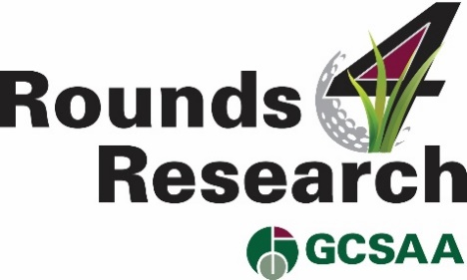
Steps | Action | Suggestions for Consideration | GCSAA Resources | Your Deadline | Person Responsible | Notes | Completed
#1 | Identify your R4R Chair and Committee | - Establish your primary team, consider current or past board members  - They will solicit donations and follow-up on requests  - They will network with allied groups and supporters  - Utilize networking events to motivate members, solicit facility participation and gain allied support  - Network with university scientists and industry partner reps | Chapter Organization Guide, FAQs and Justification piece
#2 | Generate member awareness | - Promote the auction and its importance for funding research to members in your organization  - Use articles and ads in your publications, e-messages, websites | Chapter Announcement letter, ads for chapter publications and a chapter news article
#3 | Communicate with allied groups | - Promote the auction and its importance for funding research to allied groups in your area. This helps reach potential buyers.  - Provide message for their members, links for their websites, articles and ads for their publications.  - Consider handicap reports, newsletters, university alumni outreach  - Communicate the value of customer service to the buyer when they come to play. This helps the auction continue to grow in future years. | Letter to allied organizations and message to share with their members, website content, logo, FAQs and Justification piece
#4 | Target Donors – Networking | - Create list of potential donors for your team to solicit. Consider all options.  - Incorporate support of your allied groups to identify potential donors.  - Contact university scientists for suggestions for alumni who could make a donation.  - Contact industry partners who may solicit the golf facilities on your behalf.
#5 | Communicate to Facilities  Initiate solicitations by the R4R Committee | - Assign a set of facilities from the cumulative list.  - Send letters and make a follow-up phone call or email.  - Conduct presentations at chapter and allied group meetings and events.  - For those higher end courses that can’t donate a round, solicit for a cash donation to help fund research in your area.  - Make the business case for participating – the value of a great playing surface, effective practices, products; exposure to new golfers who won the bid on the donated round. | Utilize donor form, FAQs, sample solicitation letter.  Request pre-populated donor forms for those courses who donated in 2019.
#6 | R4R Committee follow-up (solicitation forms not received.) | - If the donor form has not arrived, call or email your contact and offer to assist in completing the form for them.  - Request a pre-populated form from the EIFG for those that donated in 2019. Saves time.
#7 | Management of the Donations  Monitoring with the EIFG | - Compare your donation list to that of the donation list provided periodically from the EIFG.  - Contact the EIFG for any discrepancies to ensure all donations are accounted for.  - Send a personal email or letter on behalf of your organization for the donation.  - Remember: Thank you, thank you, thank you. We can’t say it enough. | The EIFG will provide a letter to the donating facility thanking them, as well as including tax information, posters and a window cling.
#8 | Communications to Golfers | - Utilize events and activities, including golf events/tournaments, at all donating facilities to communicate to golfers, who are your potential buyers.  - Communicate in advance and several times during the auction.  - Publish auction information in your donor facilities’ newsletters, websites, e-pushes, pro shops.  - Utilize local media with messaging about the auction and its benefit  - Request allied groups and university educators and scientists to share the information with their members, students and alumni. | Facility message for golfers, R4R ad, R4R poster
#9 | Post-Auction Communication | - Follow-up communications to the facilities via phone, emails or personal visits.  - Share information on the success, i.e. money that was raised for your organization and how it will be used. | EIFG will provide the facilities with the contact information of the winning bidder.

